Mini Project with Seminar

On

**ONLINE EXAMINATION SYSTEM**

Submitted in partial fulfillment of the requirements for the award of the

**Bachelor of Technology**

In

**Department of Computer Science and Engineering**

By

|  |  |
| --- | --- |
| **Mohd Muzammil** | **19241A0587** |
| **Jakka Arun** | **20245A0511** |
| **Sidharath Nookala** | **19241A05A7** |
| **Raj Mohan** | **19241A05B3** |

Under the Esteemed guidance of

**Dr. K. Butchi Raju, Designation**



**Department of Computer Science and Engineering GOKARAJU RANGARAJU INSTITUTE OF ENGINEERING AND**

**TECHNOLOGY**

**(Autonomous)**

**Bachupally, Kukatpally, Hyderabad-500090**

i



**Department of Computer Science and Engineering GOKARAJU RANGARAJU INSTITUTE OF ENGINEERING AND**

**TECHNOLOGY**

**(Autonomous)**

**Bachupally, Kukatpally, Hyderabad-500090**

**CERTIFICATE**

This is to certify that the mini project entitled “**Online Examinatino System**” is submitted by **Mohd Muzammil (19241A0587), Jakka Arun (20245A0511), Sidharath Nookala (19241A05A7), RajMohan (19241A05B3)**in partial fulfillment of the award of degree in BACHELOR OF TECHNOLOGY in Computer Science and Engineering during academic year 2021-2022.

INTERNAL GUIDE HEAD OF THE DEPARTMENT

**Dr. K. Butchi Raju Dr. K. MADHAVI**

Designation of guide

EXTERNAL EXAMINER

**ACKNOWLEDGEMENT**

Here there are many people who helped us directly or indirectly to complete our project

successfully. We would like to take this opportunity to thank one and all. First we would like to

express our deep gratitude towards our internal guide **Dr. K. Butchi Raju Professor**, **Department**

**of CSE** for his constant support in the completion of our dissertation. We wish to express our

sincere thanks to **Dr. K. Madhavi, HOD, Department of CSE** and also to our

**principal Dr. J Praveen** for providing the facilities to complete the dissertation. We would like to

thank all our faculty and friends for their help and constructive criticism during the project period.

Finally we are very much indebted to our parents for their moral support and encouragement to

achieve goals.

**Mohd Muzammil (19241A0587)**

**Jakka Arun (20245A0511)**

**Sidharth Nookala (19241A05A7)  
Raj Mohan (19241A05B3)**

**DECLARATION**

We hereby declare that the industrial mini project entitled **“Online Examination System”** is the work done during the period from **17th January 2022 to 14th May 2022** and is submitted in the partial fulfillment of the requirements for the award of degree of Bachelor of Technology in Computer Science and Engineering from Gokaraju Rangaraju Institute of Engineering and Technology (Autonomous under Jawaharlal Nehru Technology University, Hyderabad).The results embodied in this project have not been submitted to any other university or Institution for the award of any degree or diploma.

**Mohd Muzammil (19241A0587)**

**Jakka Arun (20245A0511)**

**Sidharath Nookala (19241A05A7)**

**Raj Mohan (19241A05B3)**

**ABSTRACT**

An online examination system is a computer-based online test simulator that allows students to take online exams. It is a web-based system that enables a school, institution, or other organisation to plan, administer, and organise exams in an online environment.

Online examination system helps students to offer a quick and easy way to attend for the test remotely from anywhere around the world. It also provides the results quickly after the examination with complete accuracy and security. Student can enter to take-up exam only with their valid username and password. This examination contains subjective, multiple choice questions.

The entire procedure of assigning tests and evaluating their answers takes a long time. In this offline system, the probabilities of question paper leak are significantly more. However, the proposed solution is far superior in terms of security and robustness.

We propose the Online Examination System to improve evaluation while reducing time and expense consumption. It also cuts down on paperwork. The results will be precise and accurate, and they will be released in a short period of time. Candidates' records and grades are saved for future reference.

**TABLE OF CONTENTS**

|  |  |  |
| --- | --- | --- |
| CONTENTS | | Page |
| No. |
| Title Page | | I |
| Declaration | | II |
| Certificate by the Supervisor | | III |
| Acknowledgement | | IV |
| Abstract | | V |
| Chapter 1: Introduction..................................................................................................... | | 1 |
| 1.1 Rationale.................................................................................................................... | |  |
| 1.2 | Goal....................................................................................................................... |  |
| 1.3 | Methodology........................................................................................................... |  |
| 1.4 | Existing Systems…………………………………………………………………. |  |
|  | 1.4.1 Less Secured ………………………………………………………………… |  |
|  | 1.4.2 Time Consuming………………………………………………………… |  |
|  | 1.4.3 Costly……………………………………………………………...……… |  |
| 1.5 | Contribution of Project........................................................................................ |  |
|  | 1.5.1 Innovativeness............................................................................................. |  |
|  | 1.5.2 Usefulness........................................................................................................ |  |
| 1.6 | Report Organization.............................................................................................. |  |

|  |  |  |
| --- | --- | --- |
| Chapter 2: System Analysis…………................................................................................ | |  |
| 2.1 | Objective..……………........................................................................................... |  |
| 2.2 | Problem Statement……………………………………………………………….. |  |
| 2.3 | Functional Requirements........................................................................................ |  |
| 2.4 | Non Functional Requirements.............................................................................. |  |
| 2.5 | Software Details………………………………………………………………….  2.5.1 Frontend Technologies……………………………………………………..  2.5.2 Backend Technologies……………………………………………………..  2.5.3 IDE………………………………………………………………………….  2.5.4 Browser…………………………………………………………………….. |  |
| 2.6 | Hardware Details………………………………………………………………… |  |
| 2.7 | Architecture……………………………………………………………………… |  |

|  |  |  |
| --- | --- | --- |
| 2.8 | Process Design………………………………………………………………….. |  |
|  | 2.8.1 Use-case Diagram......................................................................................... |  |
|  | 2.8.2 Activity Diagram........................................................................................... |  |
|  | 2.8.3 Sequence Diagram…………..……………………………………………… |  |
| Chapter 3: Implementation................................................................................................... | |  |
| 3.1 | Domain Introduction……………………………………………………………….. |  |
|  | 3.1.1 Web Development………………………………………………………… |  |
| 3.2 | Technologies Implemented………………………………………………………..  3.2.1 FrontEnd Development……………………………………………………...  3.2.2 BackEnd Development……………………………………………………… |  |
| 3.3 | Modules…………………………………………………………………………… |  |
|  | 3.3.1 FrontEnd…………………………………………………………………….  3.3.2 BackEnd……………………………………………………………………..  3.3.3 Database…………………………………………………………………….. |  |
| Chapter 4: Conclusion and Scope........................................................................................ | |  |
|  | 4.1 Conclusion......................................................................................................... |  |
|  | 4.2 Scope................................................................................................................. |  |
| References………………………………………..…………………………………..… | |  |
| Appendix………………………………………………………………………………. | |  |
| Code…………………………………………………………………………………….. | |  |

**Chapter-1**

**INTRODUCTION**

Examination is a part of every institute ,which plays a vital function in the learning process. Exams and tests are an excellent tool to assess what pupils have learned in particular subjects. Test results can also be used to determine and focus on the strengths and limitations. Assessments are used to assess a student's comprehension and grasping ability.

Computerized and online systems have been increasing in every aspect of education. Computers and internet have made dramatic changes in the education system. Information technology enables institution of high learning to save time and money, and allow the delivery of education with easiness, anywhere, and anytime.

* 1. **Rationale**

The idea of the online examination system is to manage and conduct exams. The reason to develop this project is to add security and reduce cost in comparison to the traditional pen-and-paper examination, such a technique avoids logistical challenges and disadvantages. Every student with basic knowledge can attend it on their own device in a certain amount of time.

* 1. **Goal**

The aim of our project is to reduce the cost,cheating and build a secure application to conduct exams.

* 1. **Methodology**

To solve the problem we have build a web application that acts as interface for exams.This application has frontend interface that interacts with the user,backend for business logic and a database to store the data of users.

We have developed our idea by using waterfall methodology. The waterfall methodology uses a sequential approach to software development. The traditional waterfall model divides the life cycle into stages. This paradigm assumes that one phase can begin after the preceding phase has been completed,that is the output of one stage will be used as the input of the next stage.We can’t go back to any stage and the phases do not overlap with each other.

**Stages of Waterfall model :-**

* Requirement analysis
* Design
* Implementation
* Integration and Testing
* Maintenance
  1. **Existing System**
     1. **Less Secured**

There is a substantial risk of question paper leakage in the existing system.There is a need of lot of security at each stage of exam conduction.The answer sheets must be kept secured after exam for correction or evaluation.If it is a large exam

* + 1. **Time Consuming**

The existing system is time consuming because the manual correction takes a lot of time and the results are not released soon.Students have to wait which is not good idea to track the performance of pupils.

* + 1. **Costly**

To conduct offline examinations, we require adequate and separate resources, test facilities, furniture, and other accessories.We need to have 24/7 security of question paper and invigilators to monitor students during exams.The cost of this type of exam is high in comparision to the proposed system.

* 1. **Contribution of Project**
     1. **Innovativeness**

The innovativeness of our project is to add security and develop an Online Examination System that is extremely beneficial in any institute. This project facilitates the completion of a secure and validated test. There is extremely less probability of question paper leaking, and answers of any of the questions cannot be changed after the exam.

**1.5.2 Usefulness**

With the current system's flaws in mind, the proposed solution is developed to solve the majority of them.Our proposed System is Online Examination System which is very useful in conducting exams effectively.It help to reduce time and results are released quick.The main advantage is we can conduct all types of exams in our system, students can’t switch between tabs The is very low when compared to the existing system.

* 1. **Report Organization**

The main idea of our project is to convert all forms of exams into digital exam which are very user friendly and has many advantages.The proposed system is web application build using web technologies . Online Examination System is designed and developed for students and lecturers. The system helps students to take examination. It also allows lecturers/teachers to upload the questions in the database.

**Chapter-2**

**SYSTEM ANALYSIS**

**2.1 Objective**

This project is aimed at developing an online examination system for introduction to management for students and lecturers. The purpose of the system is to completely automate the old manual procedure of conducting exam to a computerized System. I will provide a more efficient examination system.

**2.2 Problem Statement**

Design a web application that acts as an interface to manage and conduct exams by Teachers to assess students.

**2.3 Functional Requirements**

There are three sub modules in this phase. The functionality of each module is as follows:

**Student module**:

The candidate will login to the software and take his examination. He can also check his previous examinations marks and his details. The candidate will get result immediately after the completion of the examination.

**Teacher module**:

The teacher will login into the system and schedule exams for the students. He can upload questions which are stored in the database. Teacher can also add a new course , view marks of all students

**Administrator module**:

The administrator collects all the results after successful completion of the examination and sends to the head quarters as and when required.

**2.4 Non Functional Requirements**

* The application should support one device per user.
* Without being attacked for breaching, the user information should be secure..
* Server should handle large traffic when exam is being conducted.
* The software shall support use of multiple users at a time.
* The Web application should have reliability, portability, flexibility.
* System should be user friendly, so that any user can use and access the system with easiness.
* The database may get crashed at any certain time due to virus or operating system

failure. Therefore, it is required to take the database backup.

**2.5 Software Details**

The web application is build using the below technologies

**2.5.1 Frontend technologies**

* HTML (Hypertext markup language)
* CSS (Cascading Style Sheets)
* JavaScript

**2.5.2 Backend technologies**

* Django (Python Framework)
* SQLite (Database)

**2.5.3 IDE (Integrated Development Environment)**

* Visual Studio Code

**2.5.4 Browser**

* Google Chrome

**2.6 Hardware Details**

* RAM : 4GB
* Processor : Intel i3

**2.7 Architecture**

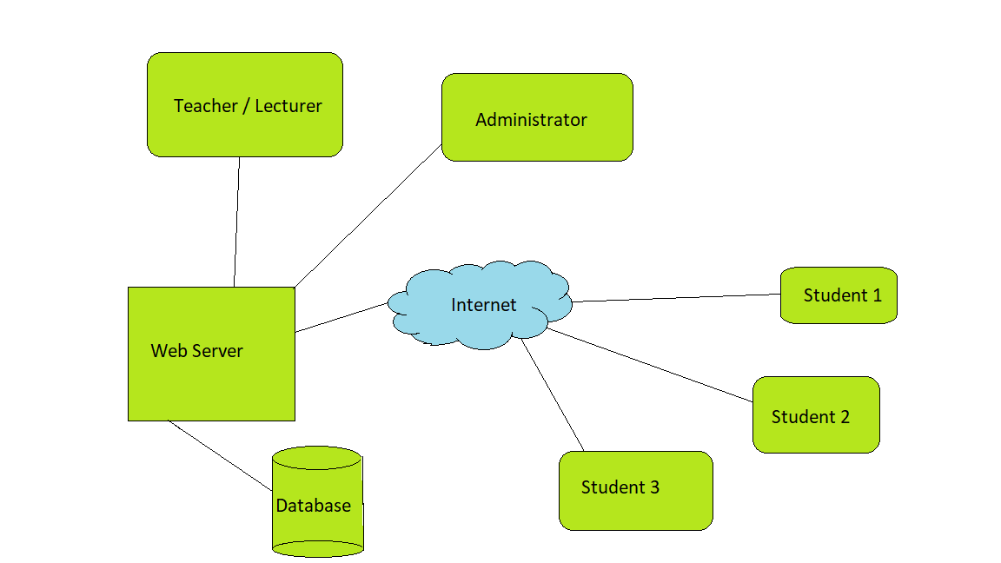

**2.8 Process Design**

**2.8.1 UseCase Diagram**

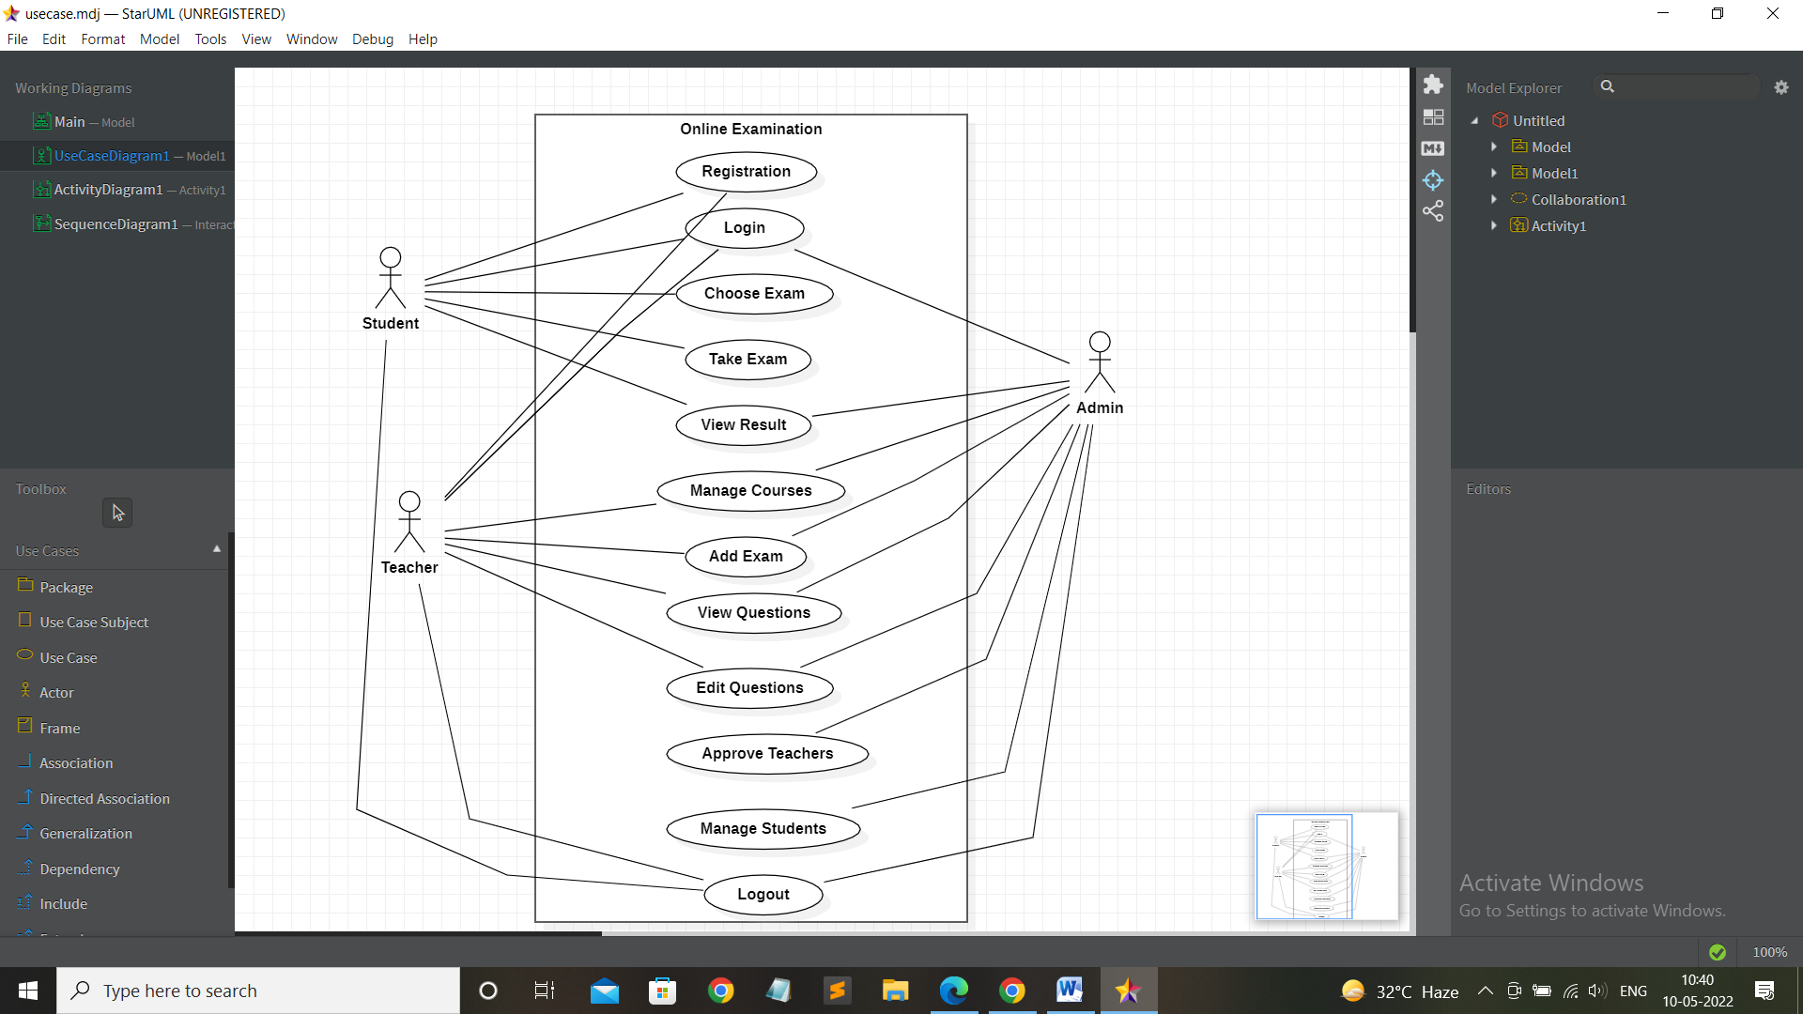

**2.8.2 Activity Diagram**

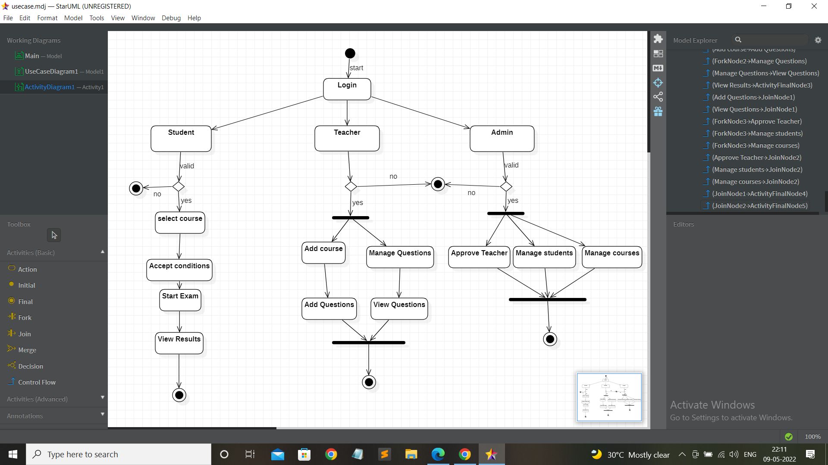**2.8.3 Sequence Diagram**

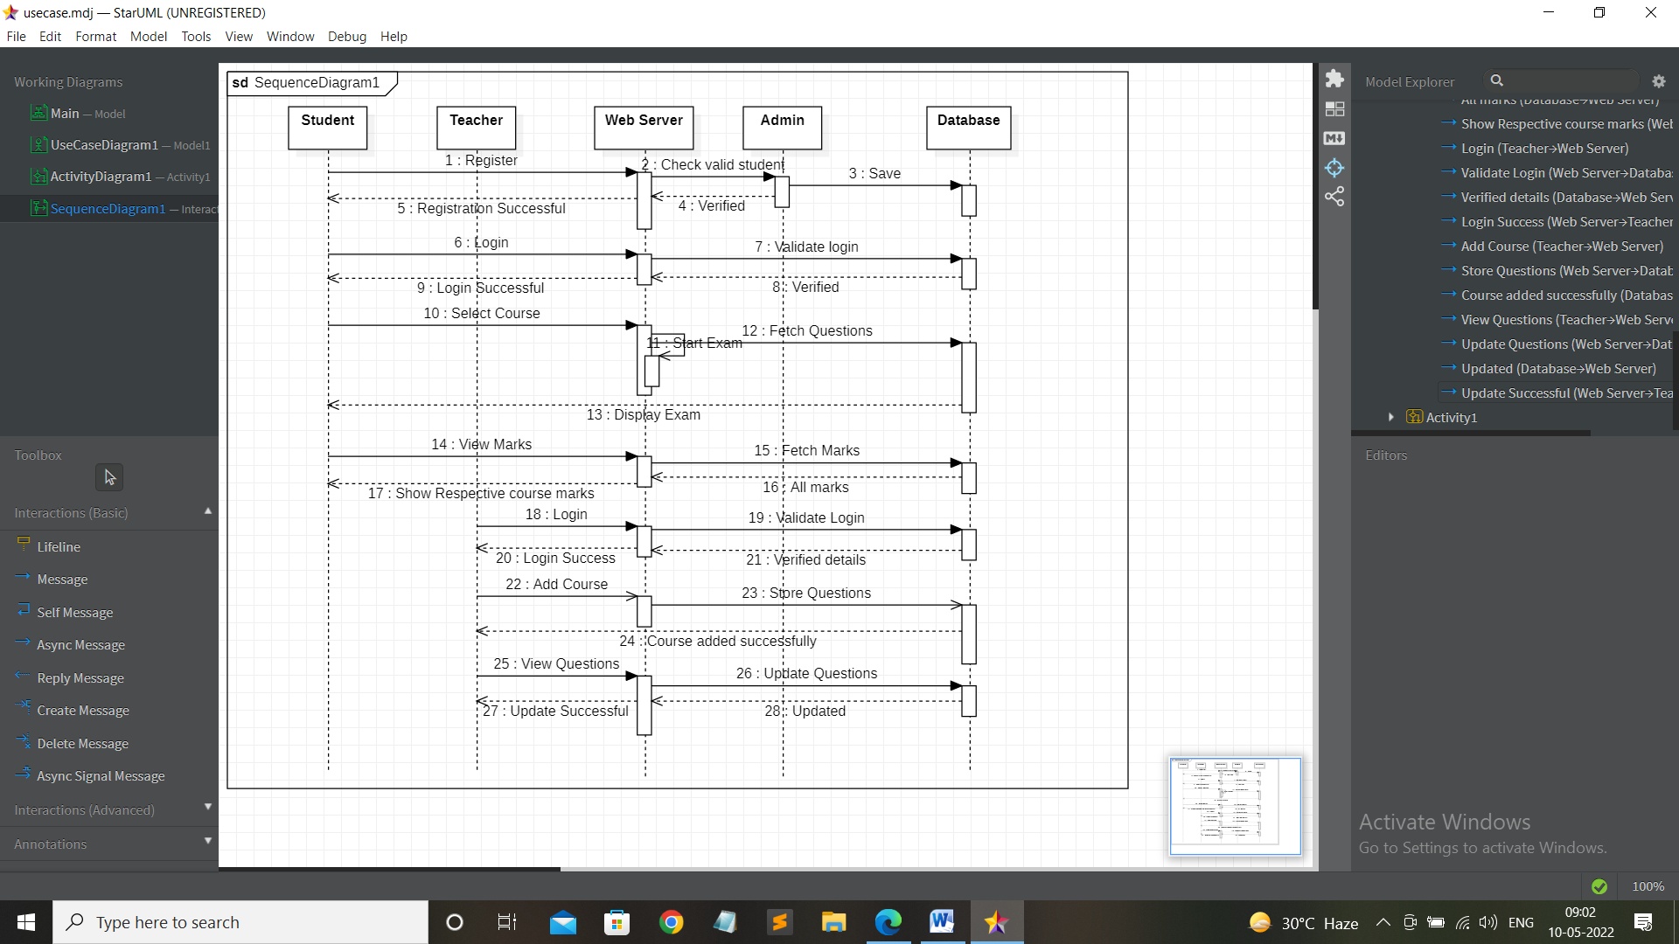

**Chapter-3**

**IMPLEMENTATION**

**3.1 Domain Introduction**

**3.1.1 Web Development**

Web development encompasses all of the tasks involved in creating websites for intranet or internet hosting. The web development process includes web design, website content creation, client-side/server-side programming, and networking security settings. Web development, in a wide sense, refers to all of the actions, changes, and operations necessary to create, maintain, and manage a website to guarantee optimal performance, user experience, and speed. Web development is a great tool for businesses since it provides numerous options to grow. It has allowed people from all over the world to engage and build their businesses without boundaries.

* Web development is a powerful tool for organisations that leaves a lasting impression. A website that is well-designed and responsive is more likely to win user trust and attract a wider audience.
* Web development is a one-time investment that saves both time and money. You don't need to invest extra money to increase sales or advertise your business.
* Expand Your Reach: Web development allows you to branch out from your local area and expand your firm globally.
* More Sales: Most firms have seized the chance to profit from online sales and gain a competitive advantage of web.

**3.2 Technologies Implemented**

**3.2.1 Frontend Development**

The part of web development that focuses on what users view on their end is known as frontend development. It entails transforming backend developers' code into a graphical interface and ensuring that data is displayed in an easy-to-read and comprehend style. People without a coding experience, on the other hand, may easily comprehend and utilise online apps and webpages.

**3.2.1.1 HTML**

The HTML stands for Hyper Text Markup Language. Hypertext means linking webpages. Markup language means text document written in the tags. The HTML defines the structure of web pages. It is a standard language for developing web pages. The latest version of HTML is HTML5. The language consists of various elements and tags. These elements define the way in which content to be displayed by the browser.

The basic tags of HTML are

* DOCTYPE
* HTML
* HEAD
* TITLE
* BODY

**Features**

* It is a platform independent language.
* It is easy to learn and understand.
* Multi media like audio, video and images can be added to web page.

**3.2.1.2 CSS**

The CSS stands for Cascading Style Sheet. It changes the look and presentation of webpages. It makes the website attractive. It is used to add styles to webpages. It can be used to manage layout of multiple webpages. The latest version of CSS is CSS3.

The types of CSS are

* Inline
* Internal
* External

**Advantages**

* It saves the time by reusing same style to multiple pages.
* It makes the webpage load faster.
* It is easy to maintain
* It adds various styles to html pages.

**3.2.1.3 BOOTSTRAP**

The bootstrap is a CSS framework. It is used to develop responsive websites. The responsive websites automatically adjust themselves to various devices. It is front-end framework. It includes design templates for web development. The latest version of bootstrap is bootstrap5.

**Advantages**

* It is used to develop responsive webpages.
* It is used to develop platform independent webpages.
* It is an opensource framework.

**3.2.1.4 JS(JavaScript)**

JavaScript is an object-oriented scripting language. It is light weight. It is used to develop dynamic webpages. It provides dynamic interactivity on the webpages. It can be used for both client and server-side development.

The ways to JavaScript to HTML are

* Internal JS
* External JS

The JavaScript frameworks are

* Angular
* React
* Node
* Vue
* Backbone

**Features**

* It is a lightweight interpreted language.
* It has a large following in the community
* It is used to develop both client side and server-side applications.

**3.2.2 Backend Development**

Back end development refers to web development operations performed on the back end of applications. Backend development, as opposed to frontend development, focuses on server-side web application logic and integration, as well as activities such as writing APIs, generating libraries, and working with system components. Backend developers write code that allows a database and an application to exchange data. Backend developers are responsible for the website's backend, which includes databases, servers, and apps, and they have authority over what we don't see.

**3.2.2.1 DJANGO (Python FrameWork)**

The Django is a python framework. It is used in back-end development of web application. It is very useful for building websites which are dependent on databases. It is based on MVT architecture.

Django's main purpose is to make building complex, database-driven websites easier. The framework prioritises component reusability and pluggability, as well as less code, low coupling, rapid development, and the don't repeat yourself principle.

**MVT architecture**

**Model**

It acts as an interface for the data. It contains the logic of the data in the application. It is represented by the database.

**View**

It is the user interface in the web application. It is represented by HTML, CSS, JS, etc.

**Template**

It contains the static HTML parts. It also describes how dynamic content is inserted in the webpages.

**Features**

* Secure
* Open Source
* Scalable
* Fully Loaded
* Versatile

**3.2.2.2 SQLITE**

SQLite is a self-contained, embedded SQL database engine. It needs zero configuration. It is serverless. It is an embedded relational database management system. It perform read and write operations on data directly into disk file. To connect SQLite with Python, we do not need to install the connection module separately because its being installed by default along with Python version 2.5.x onwards.

**Features**

* It is easy to configure.
* It has ACID properties.
* It is faster.

**3.3 Modules**

**3.3.1 FrontEnd**

The HTML, CSS, and Javascript files of the front-end module are used to generate UI for the client or user. We have used BootStrap form smoothness of our website.

We have created the following components**:**

* **Exam**
* Index.html
* Login.html
* Navbar.html
* Footer.html
* **Student**
* Student_dashboard.html
* Check_marks.html
* Studentbase.html
* Start_exam.htm
* **Teacher**
* Teacher_dashboard.html
* Teacher_add_exam.html
* Teacher_view_questions.html
* Teacher_add_course.html

**3.3.2 BackEnd**

BackEnd module is made up of Django web framework

Let's look at the files that were created to connect to database and execute the server

* **Exam**
* Forms.py
* Apps.py
* Models.py
* Admin.py
* Views.py
* **Student**
* Forms.py
* Urls.py
* Models.py
* Views.py
* **Teacher**
* Forms.py
* Urls.py
* Models.py
* Views.py

**3.3.3 Database**

To store & retrieve the data of our users we have used SQLite database.The following is the file name

* db.slite3

**Chapter-4**

**CONCLUSION AND SCOPE**

**4.1 Conclusion**

An Online Examination System is a Web application. The main idea is to reduce the amount of paper used and transfer all types of documents to digital format. It provides outcomes that are error-free and secure. A person with only rudimentary computer skills may easily use the system.

* 1. **Scope**
* The project's scope is quite broad.
* This may be utilised in both educational and corporate environments.
* This project may be used to administer a variety of competitive examinations.
* It is time-saving and cost-effective.
* Authentication ensures that the learner may access the software from anywhere around the world
* Can be accessed at time throughout the open test period.
* Designed for educational institutions to provide frequent examinations to their pupils.

**References**

[1] https://en.wikipedia.org/wiki/Web_development

[2] https://www.w3schools.com/html/

[3] https://www.w3schools.com/css/default.asp

[4] https://www.freecodecamp.org/news/full-bootstrap-5-tutorial-for-beginners/

[5] https://www.javatpoint.com/javascript-tutorial

[6] https://www.tutorialspoint.com/django/index.htm

[7] https://docs.djangoproject.com/en/4.0/intro/tutorial01/

[8] https://www.geeksforgeeks.org/django-project-mvt-structure/

[9] https://www.sqlitetutorial.net/

[10] https://docs.python.org/3/library/sqlite3.html

**APPENDIX SCREENSHOTS**

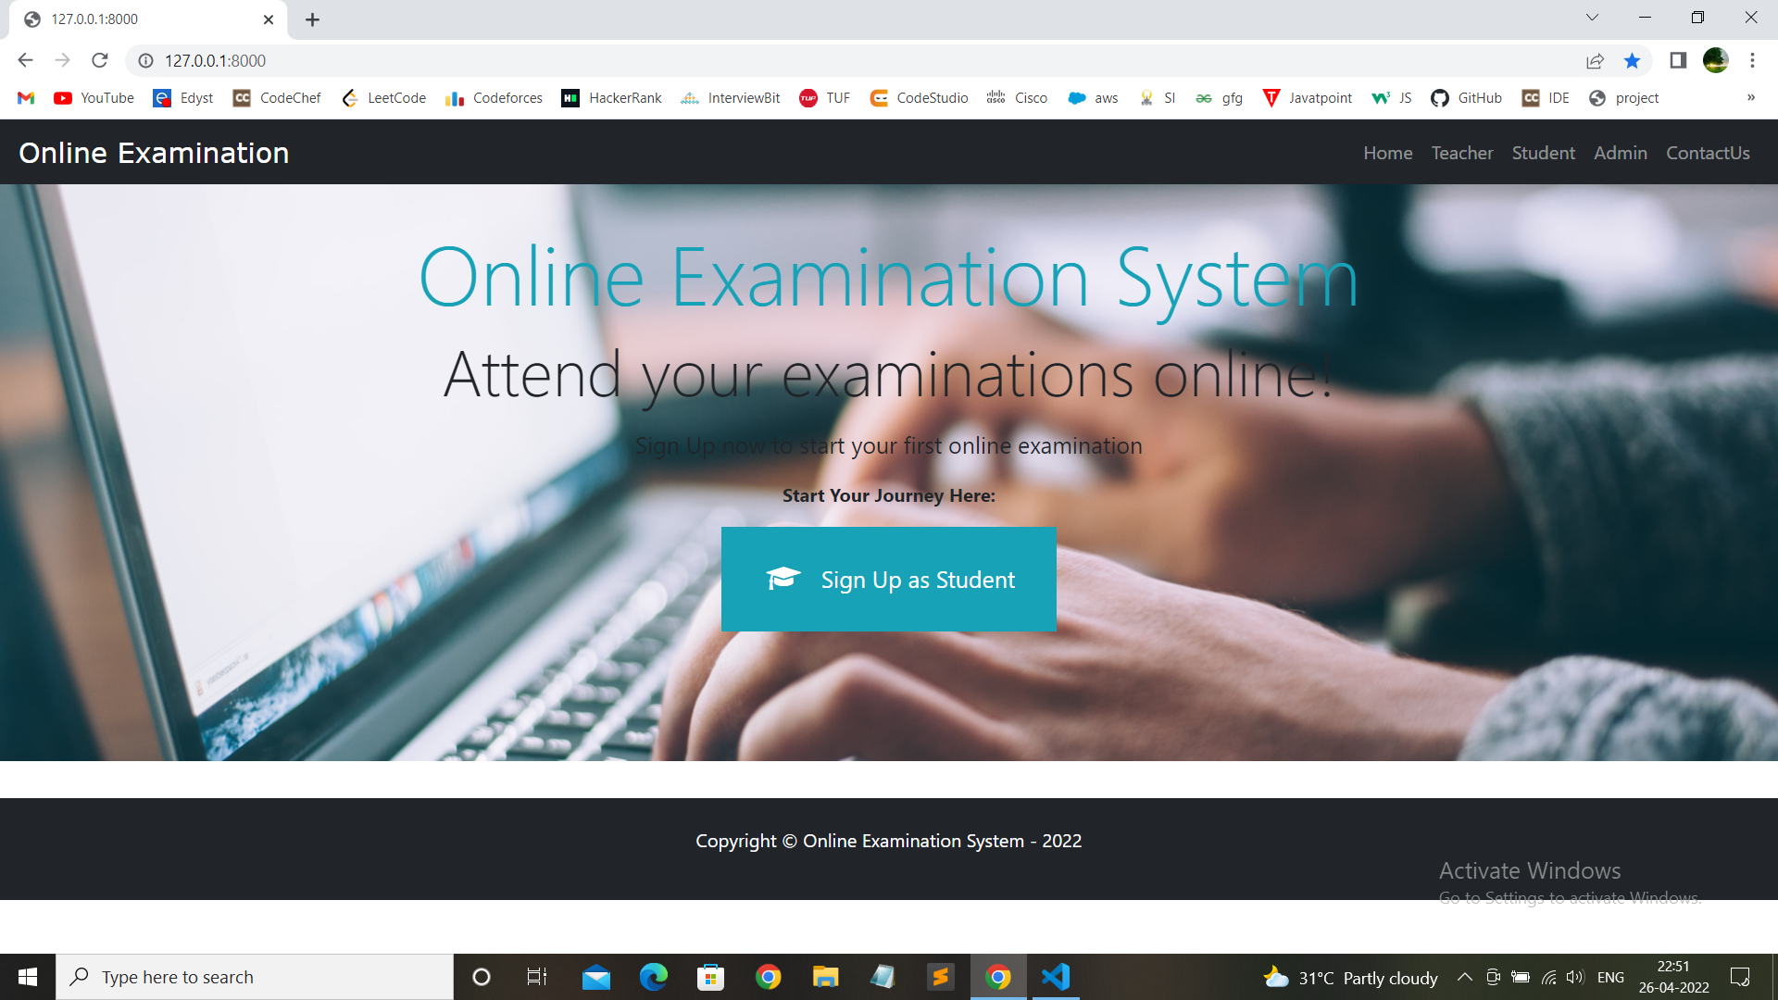

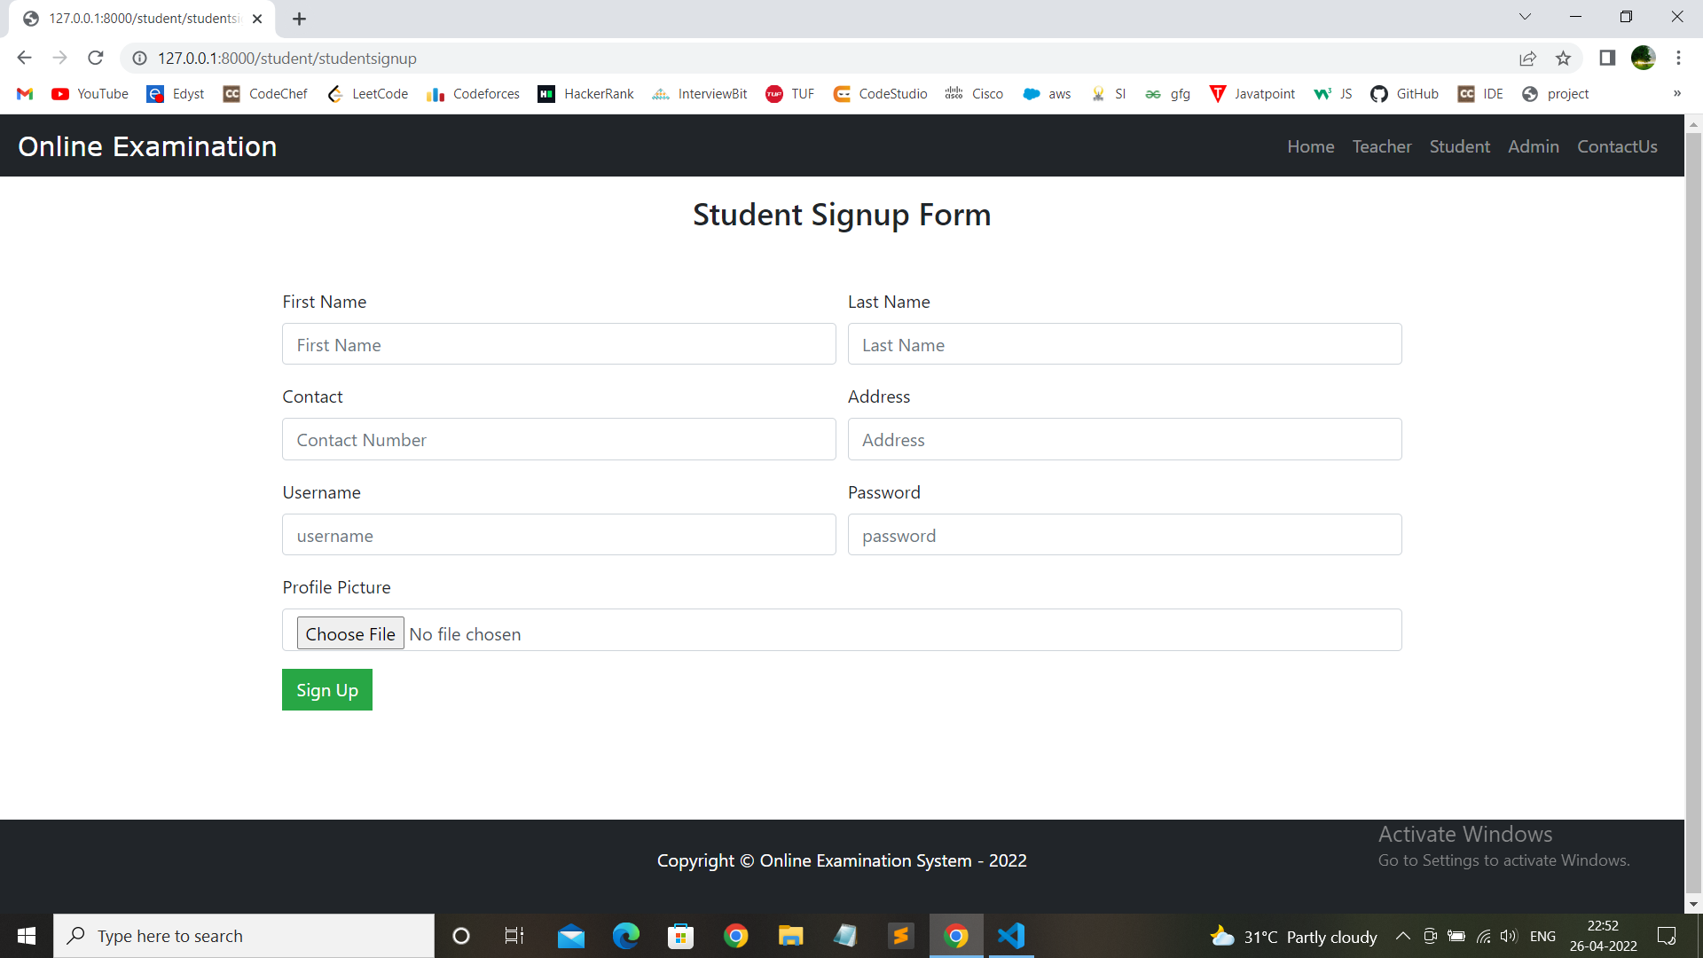



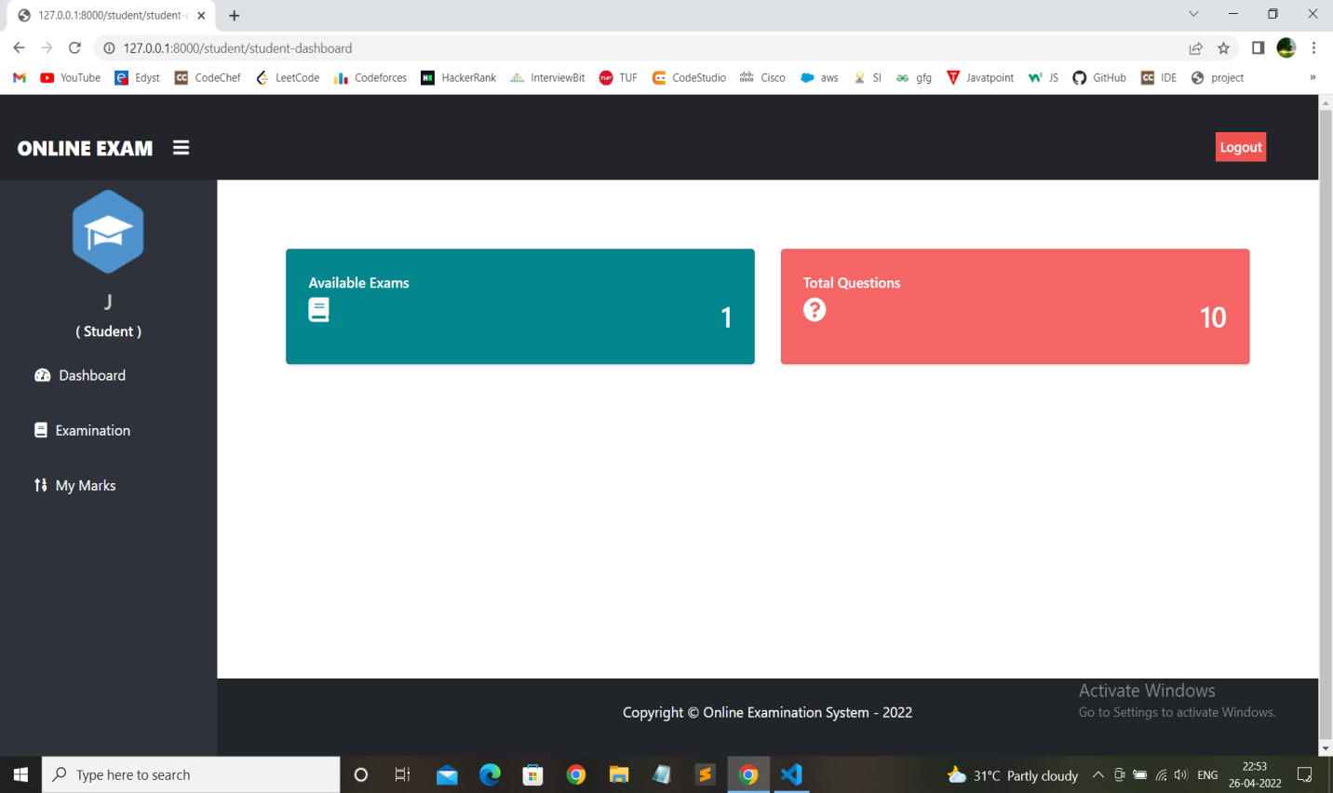

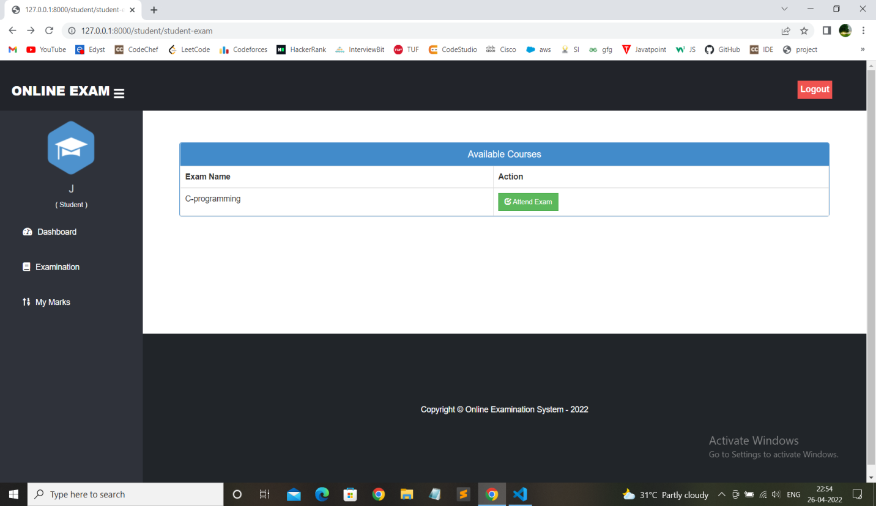

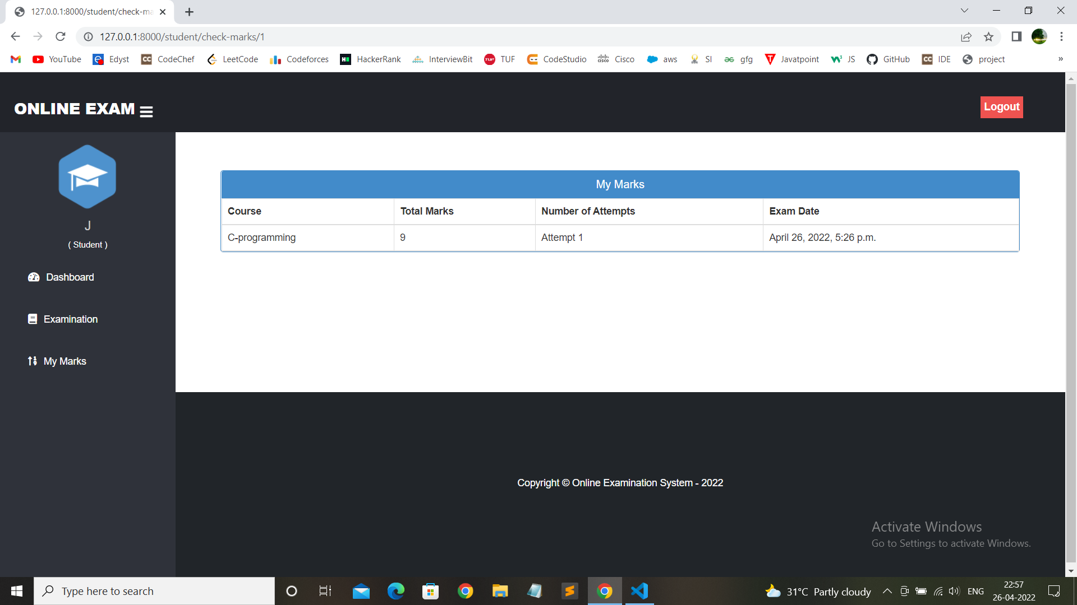

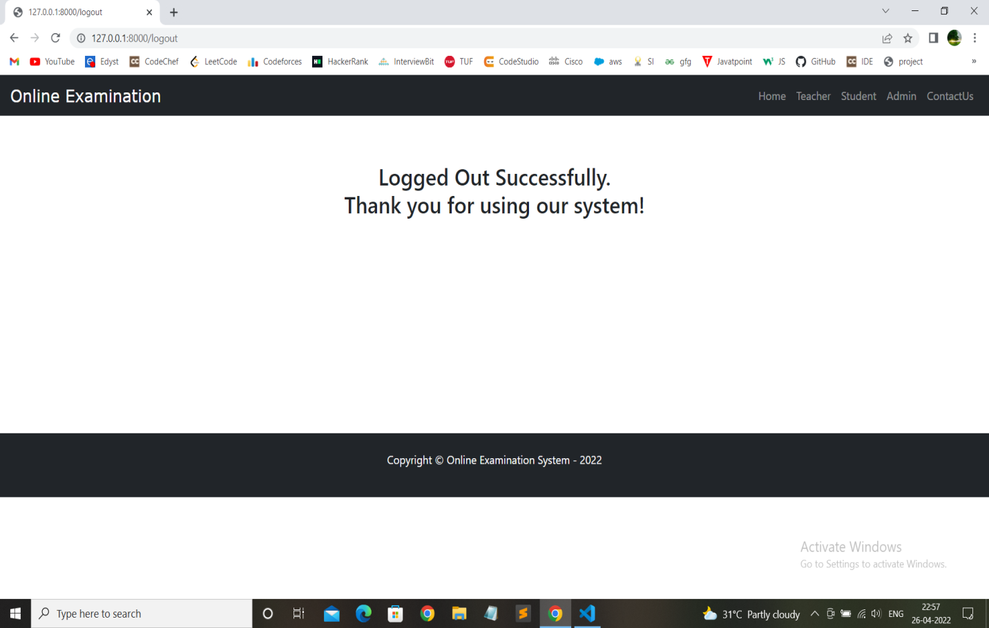

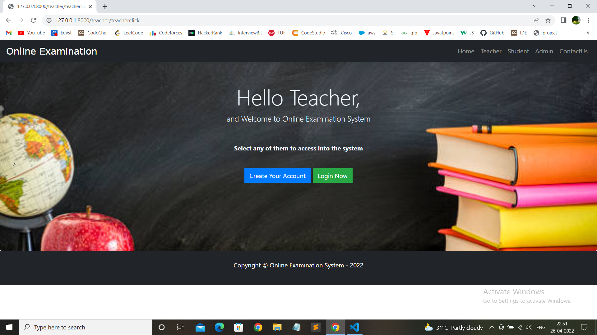

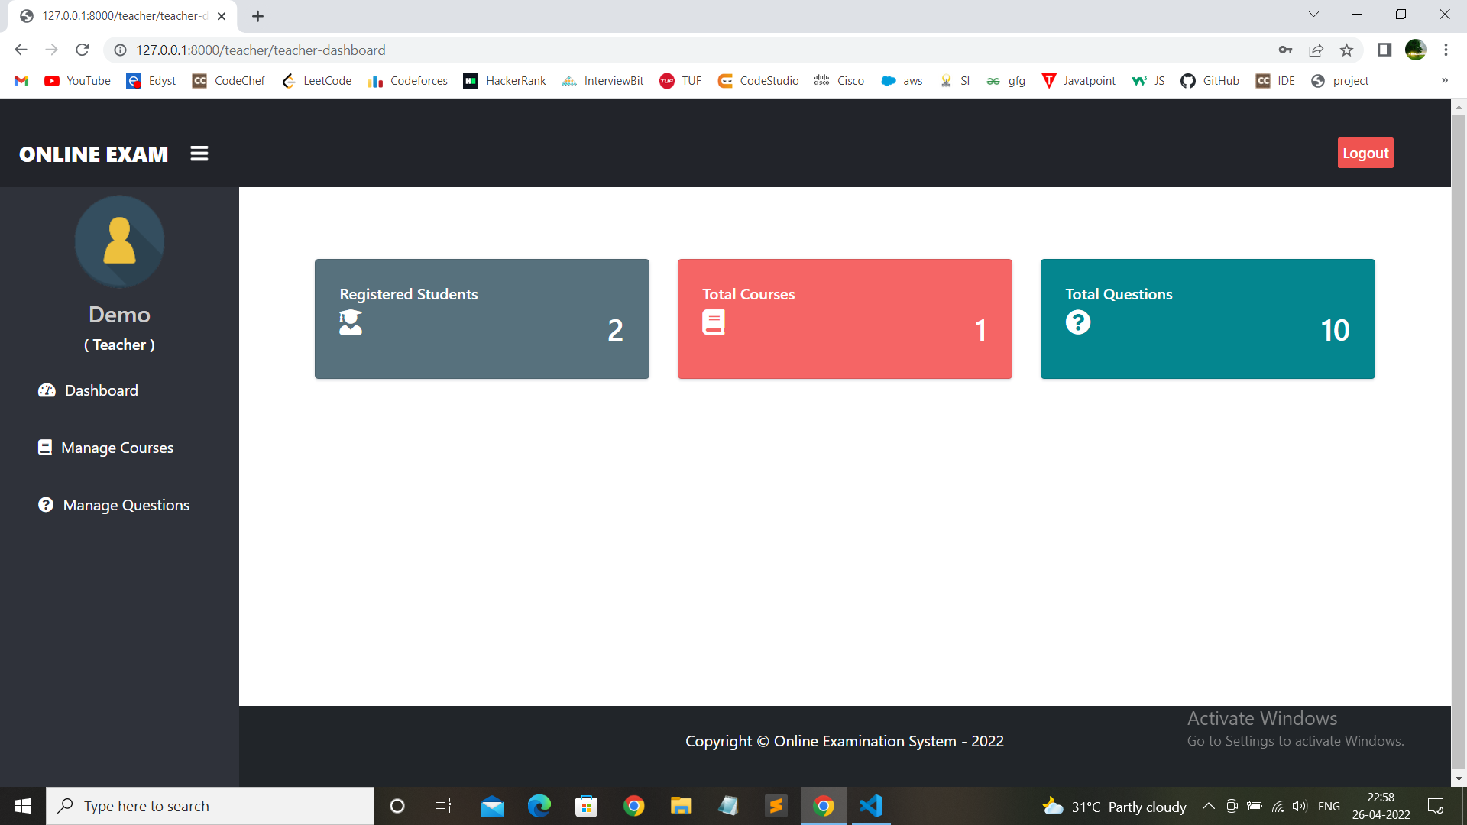

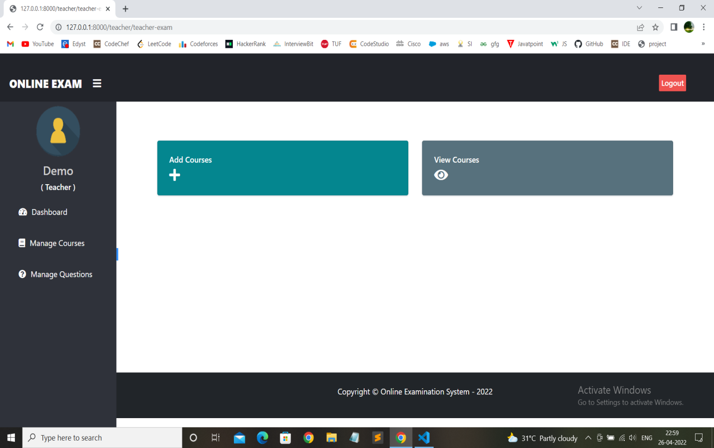

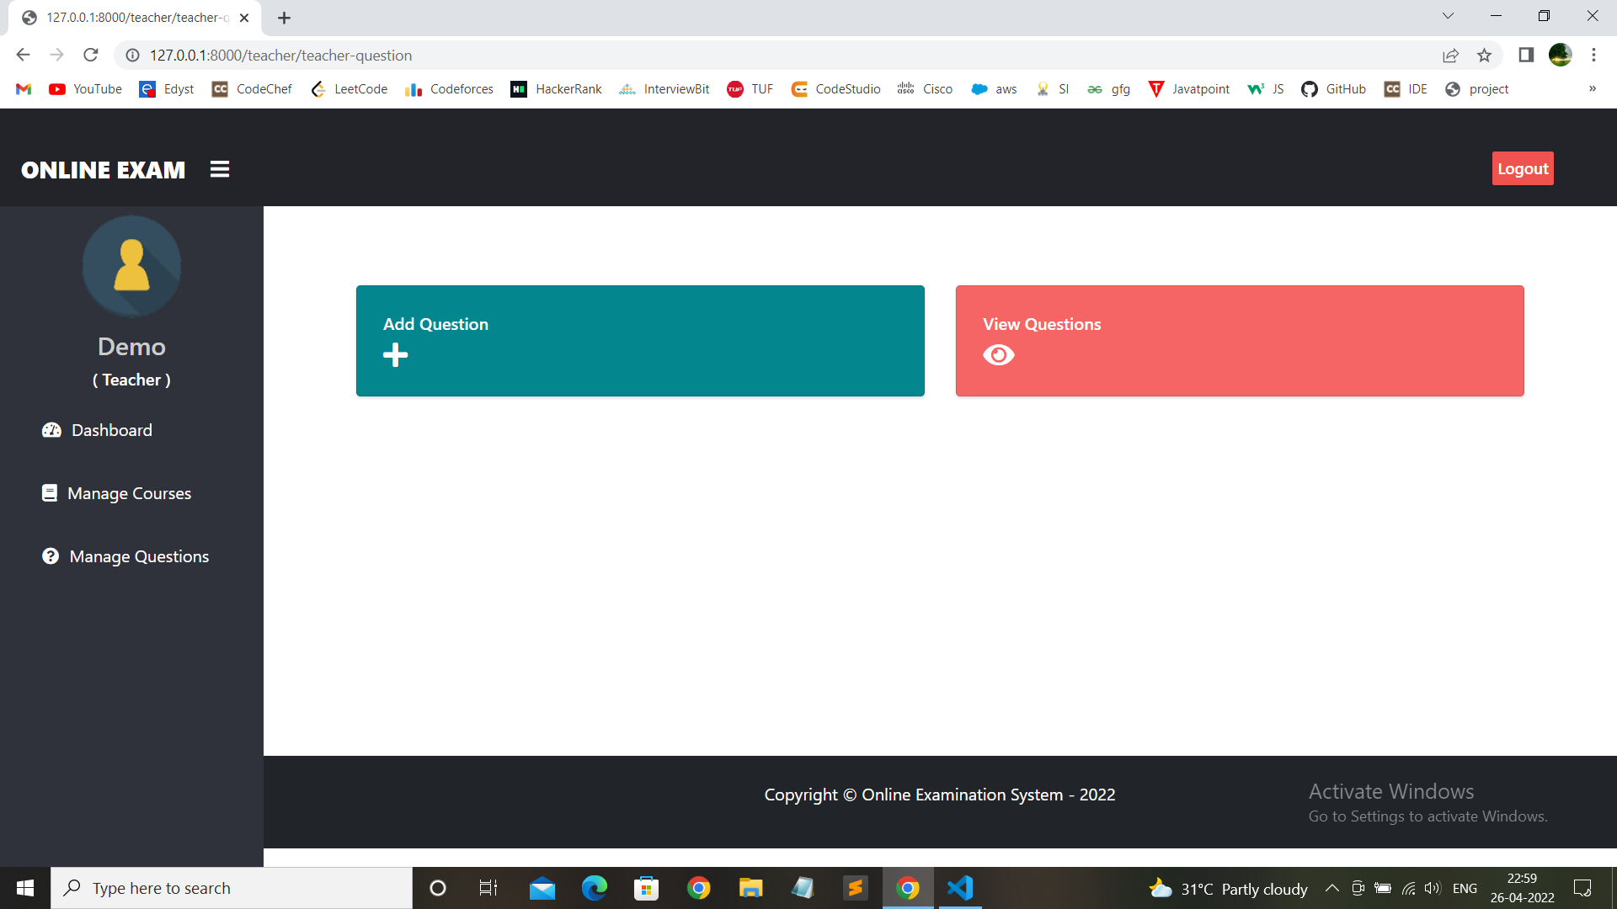

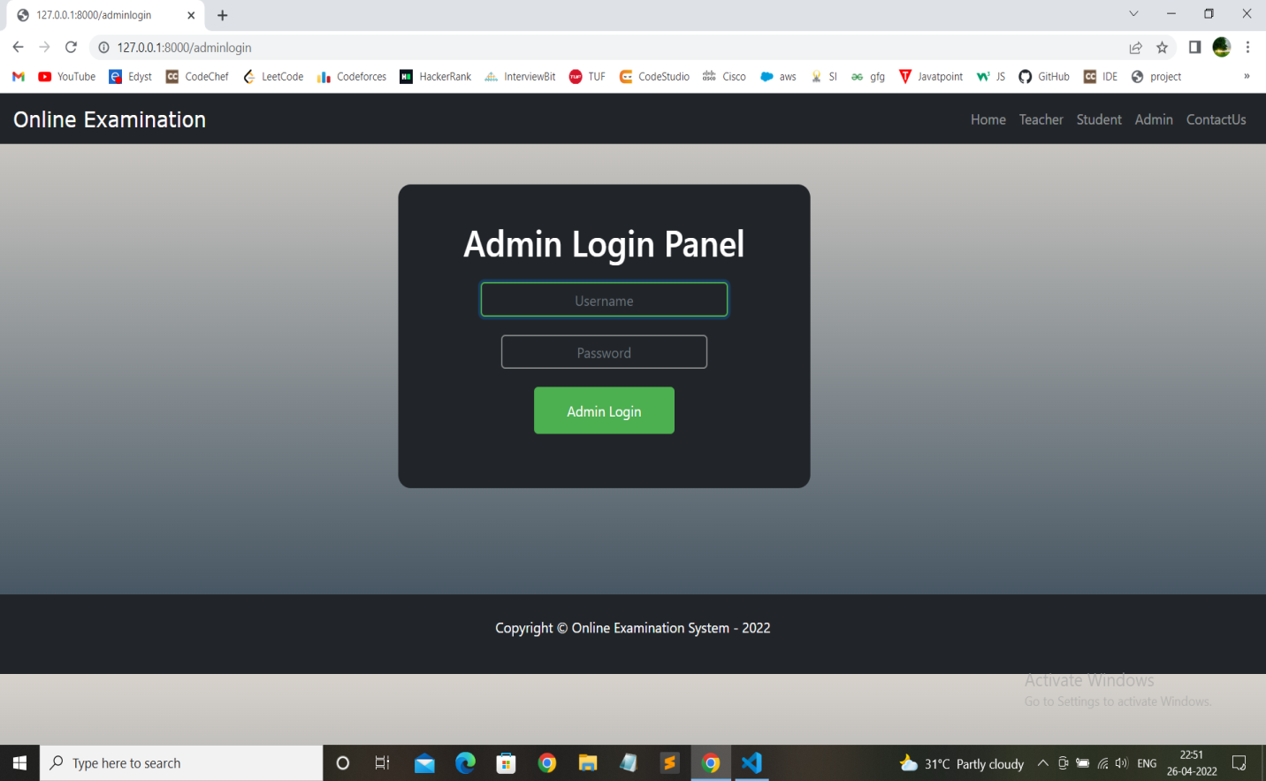

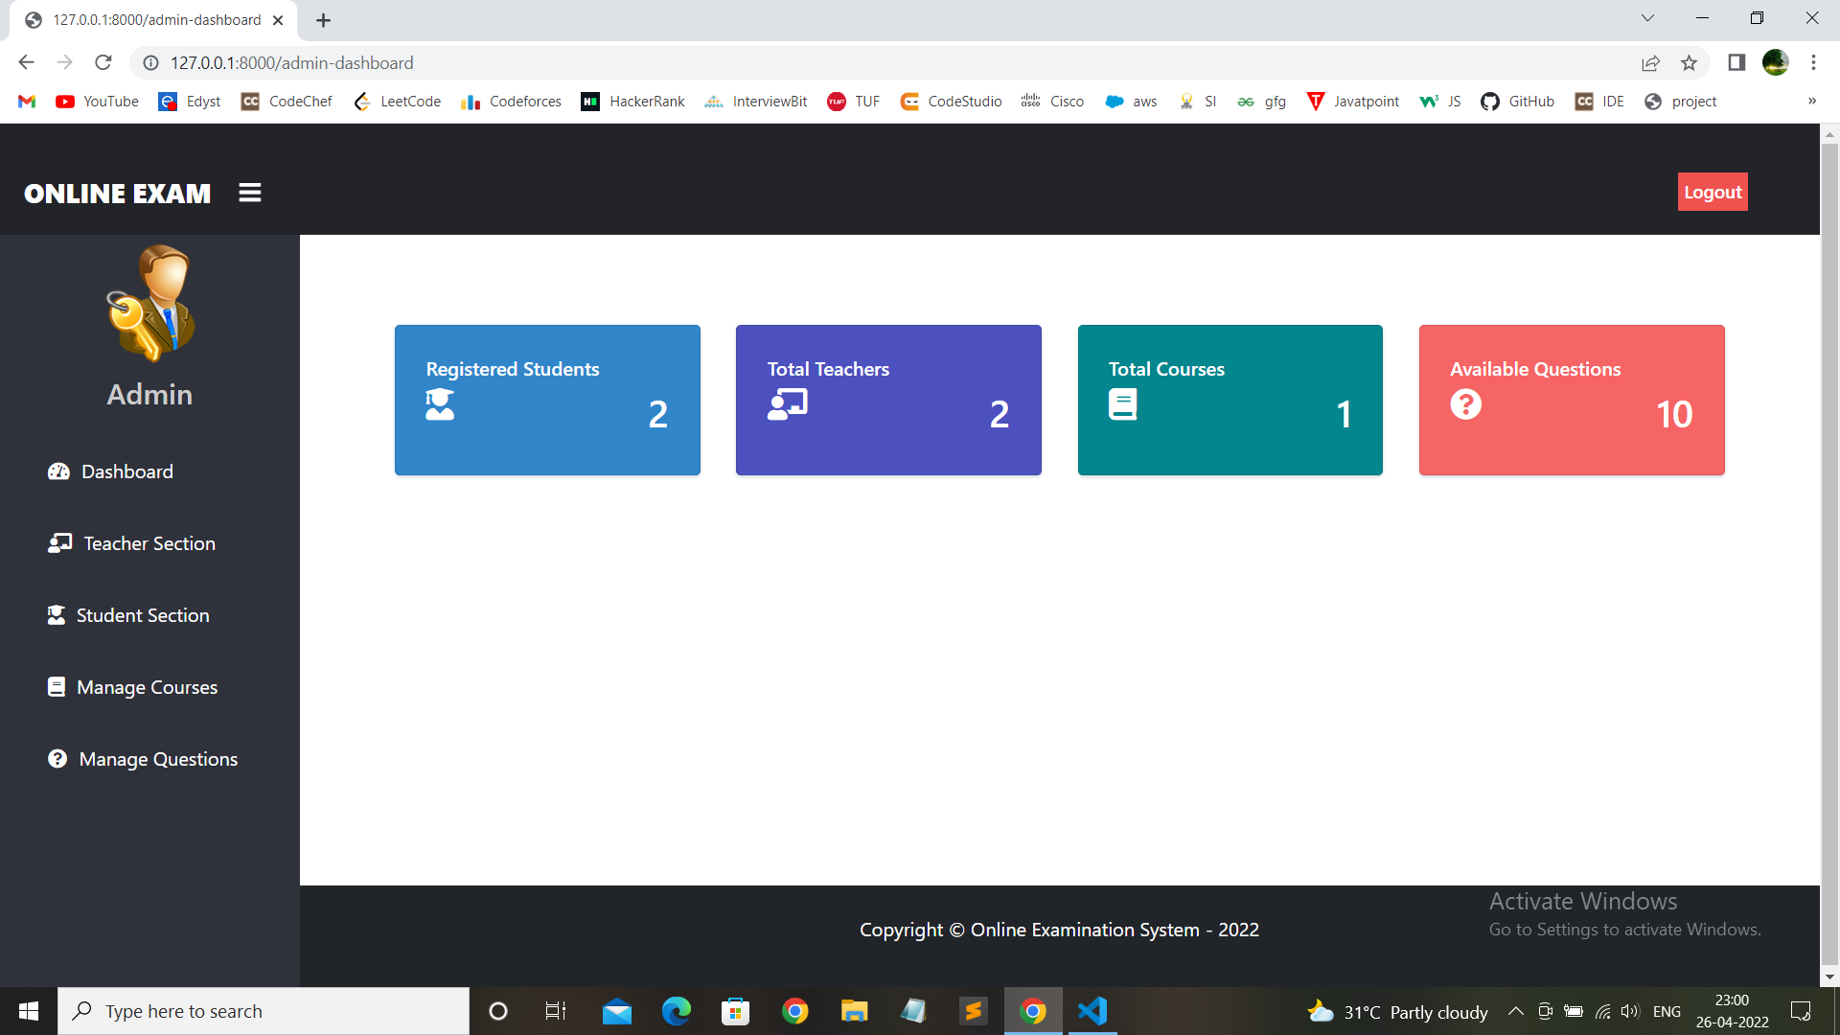

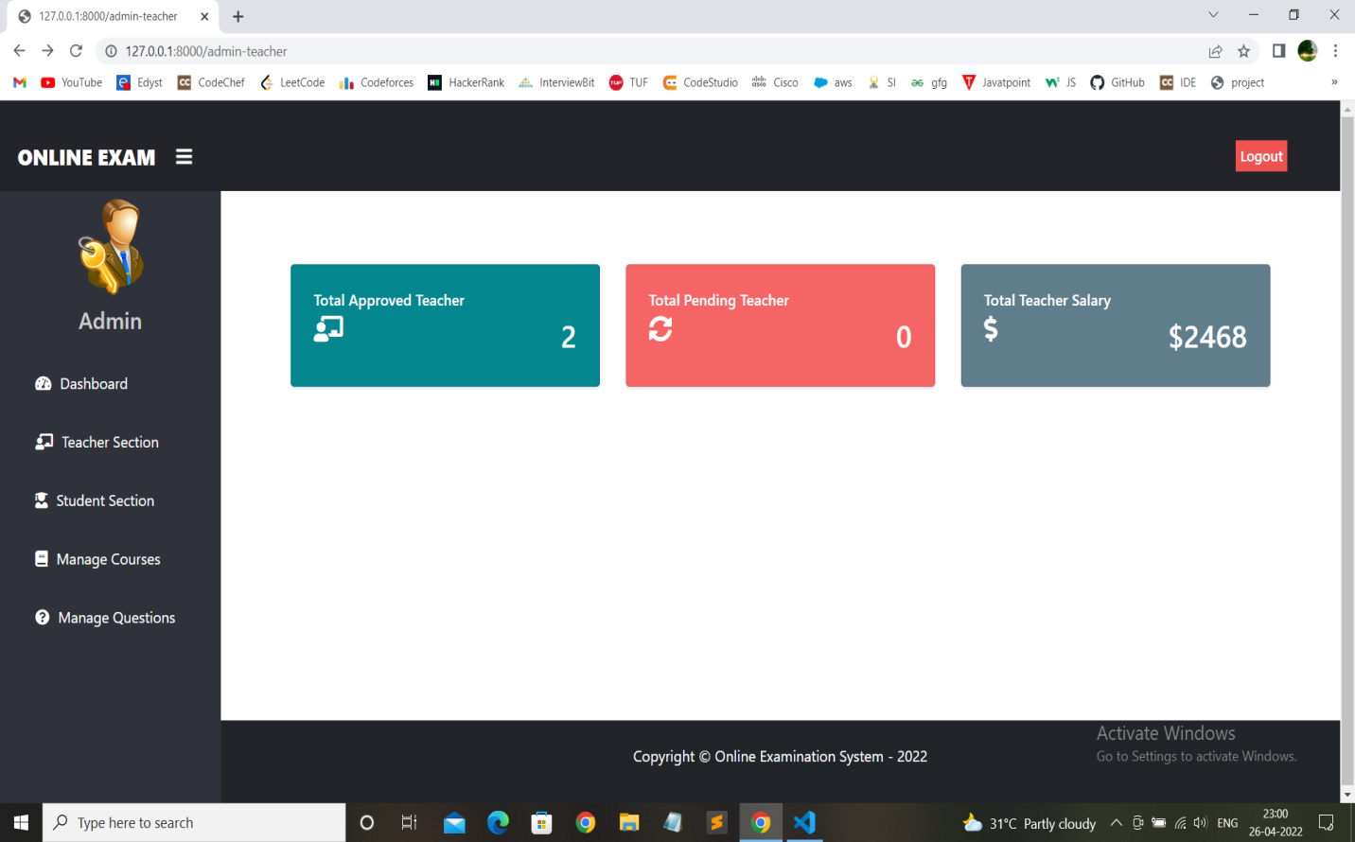

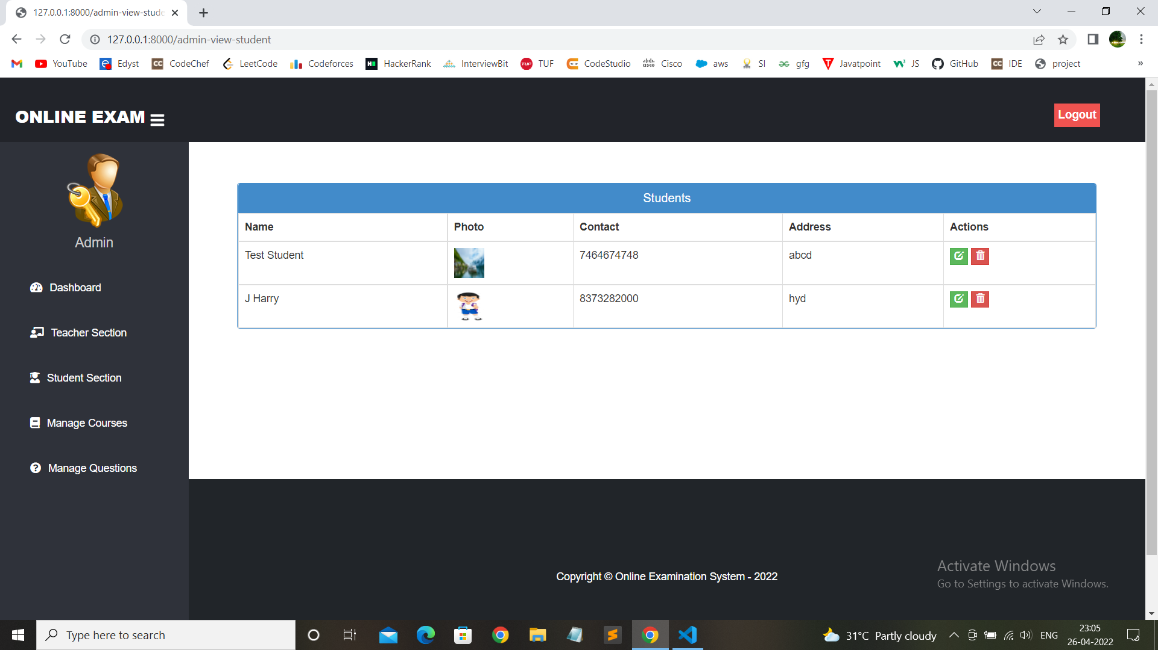

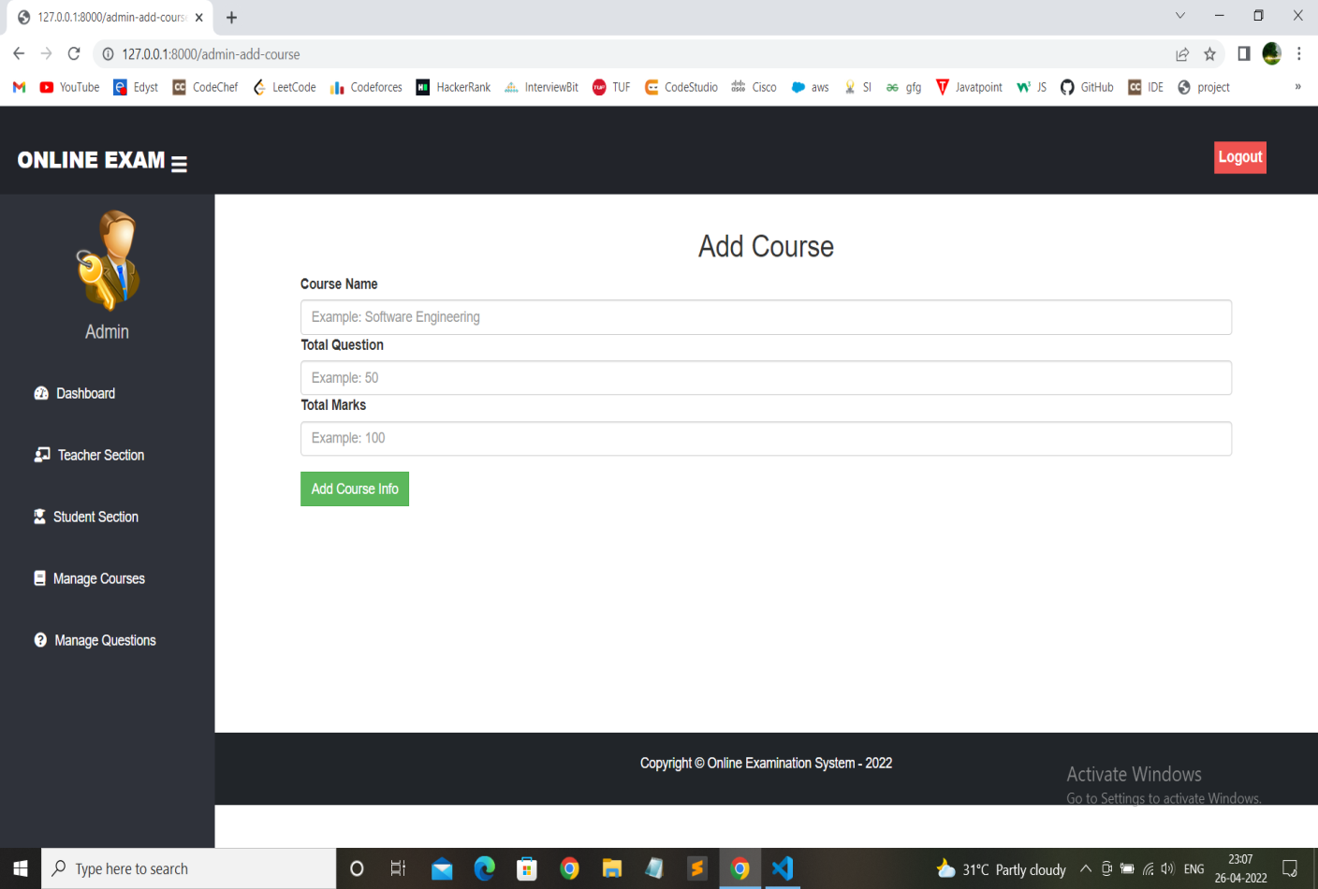

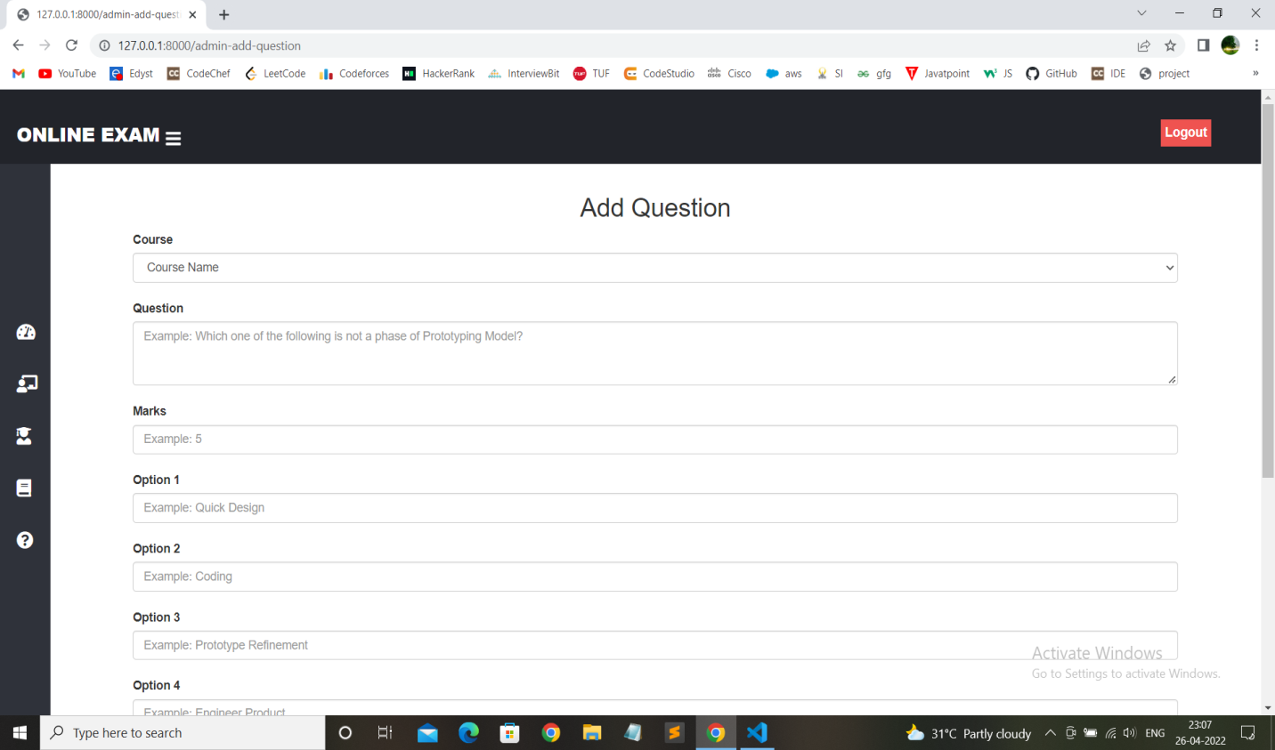

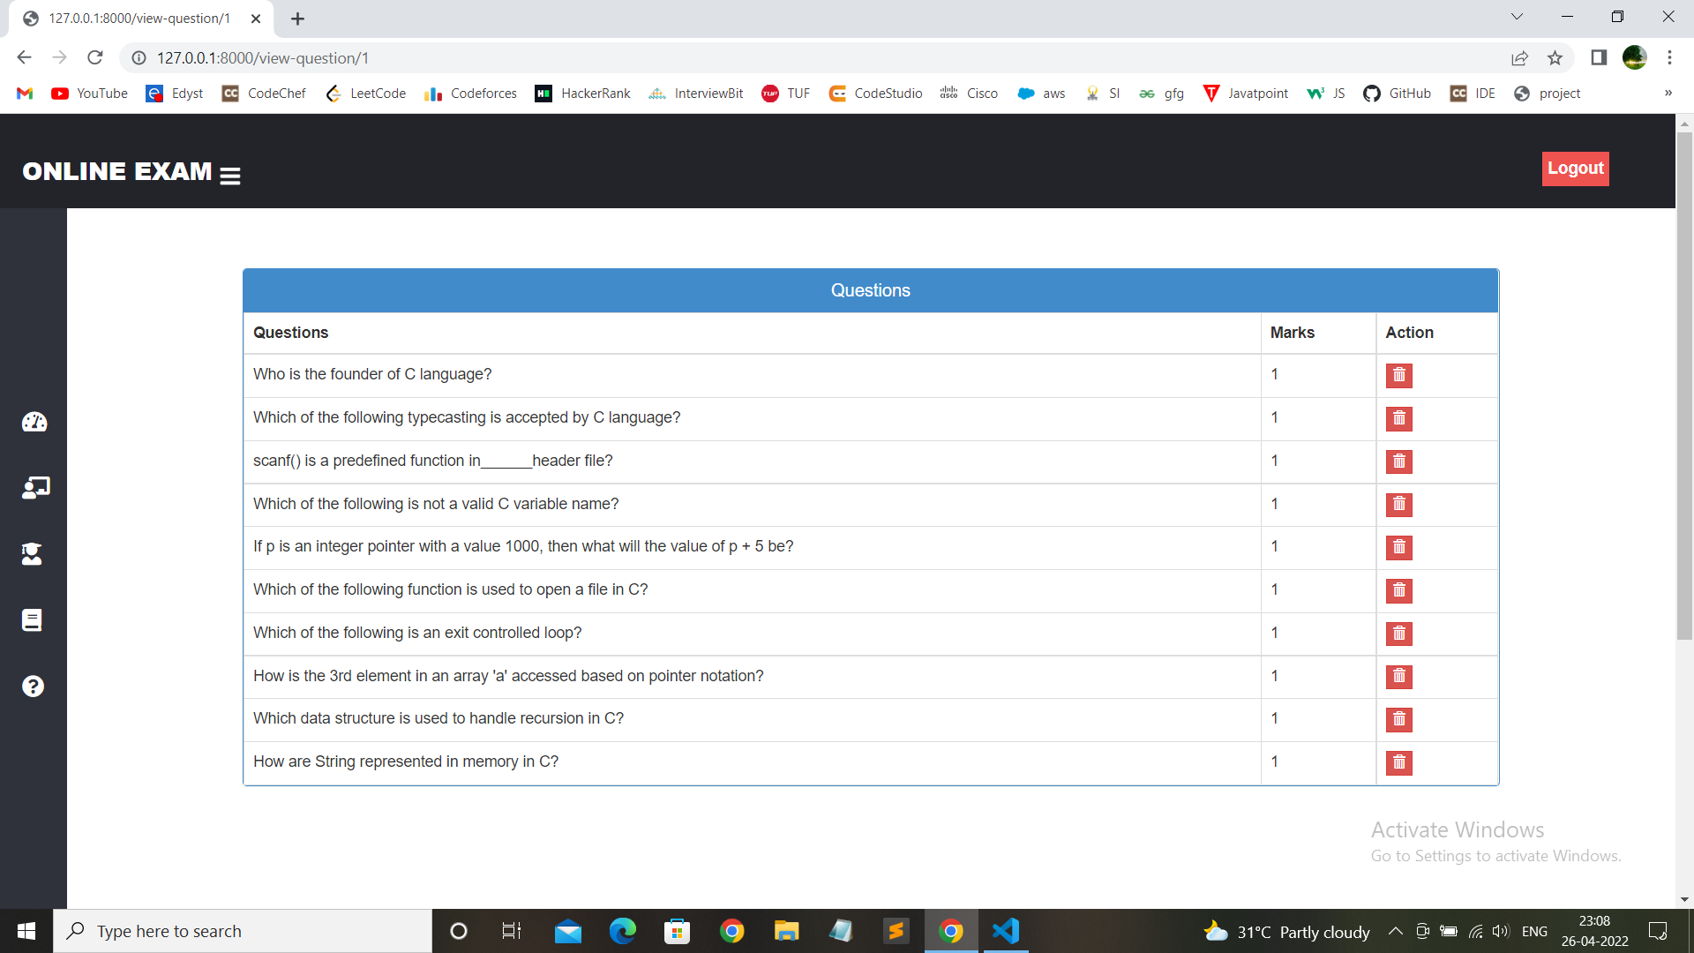

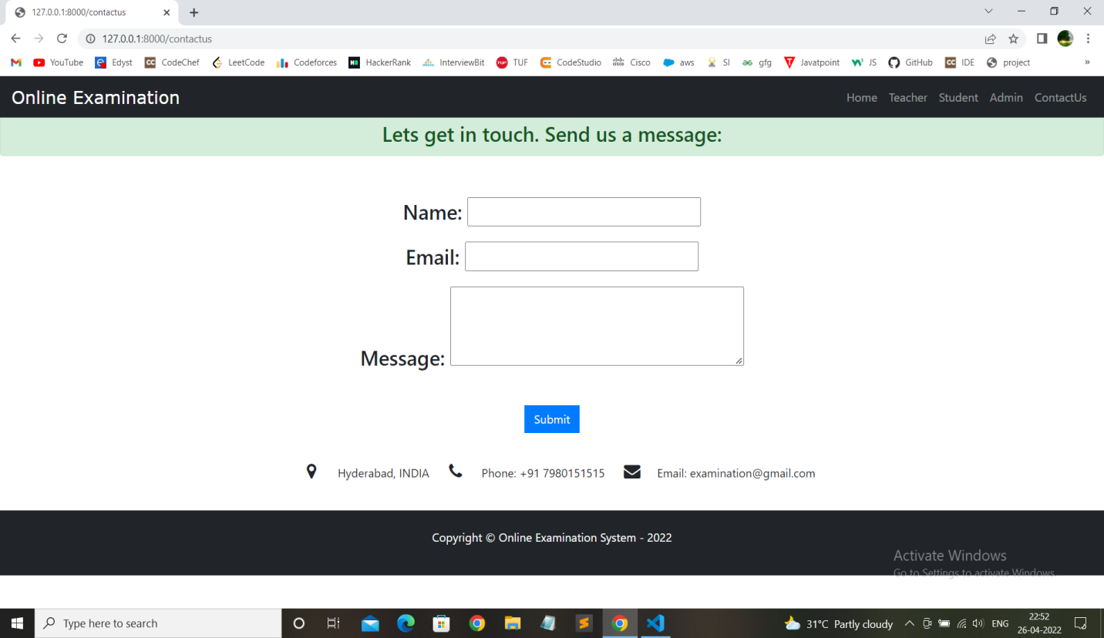

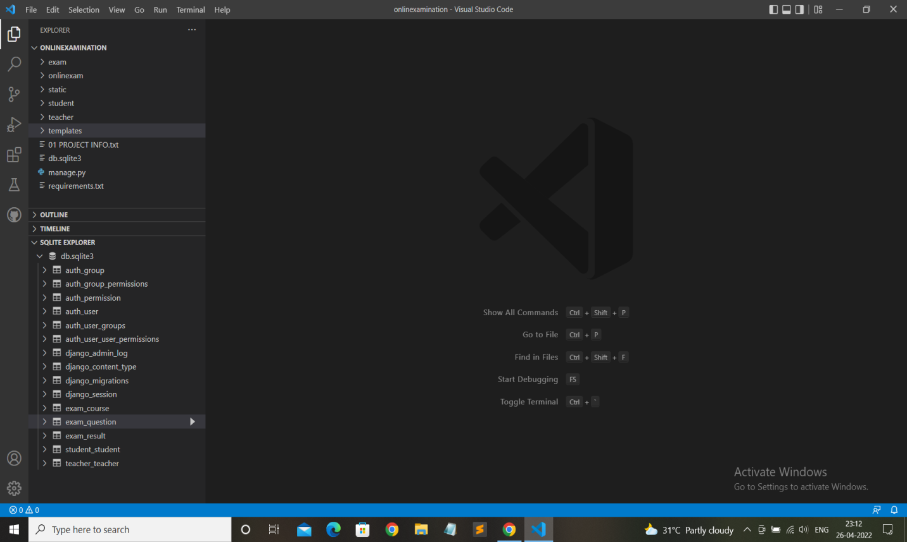

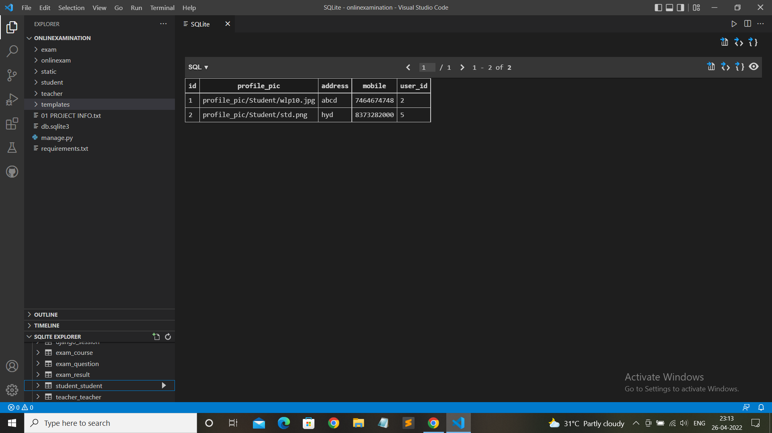

**Code**

